Vinoliah Makamu : Practical exercise (Google BigQuery) Dataset: Retail Sales Dataset
NB: Checking the table
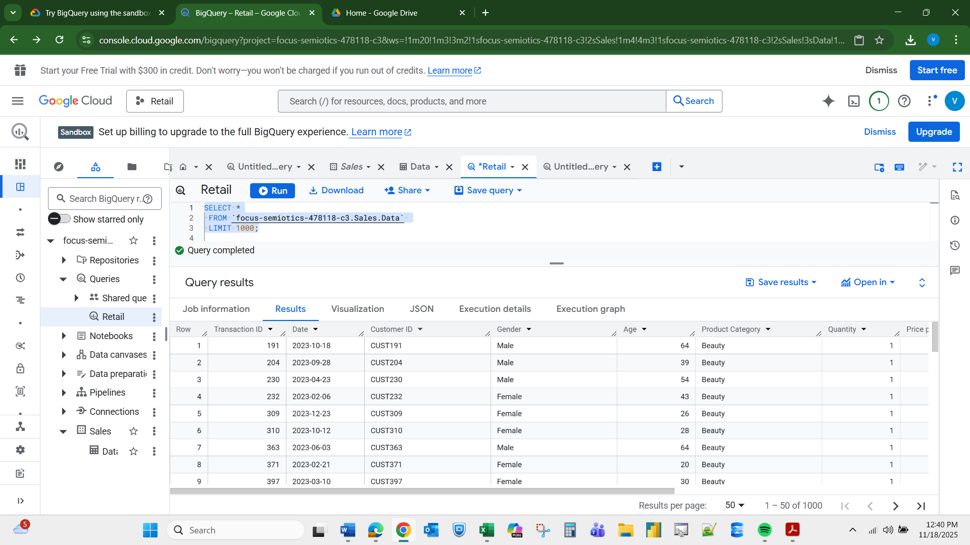
Question 1.Filter all transactions that occurred in the year 2023. Expected output: All columns.

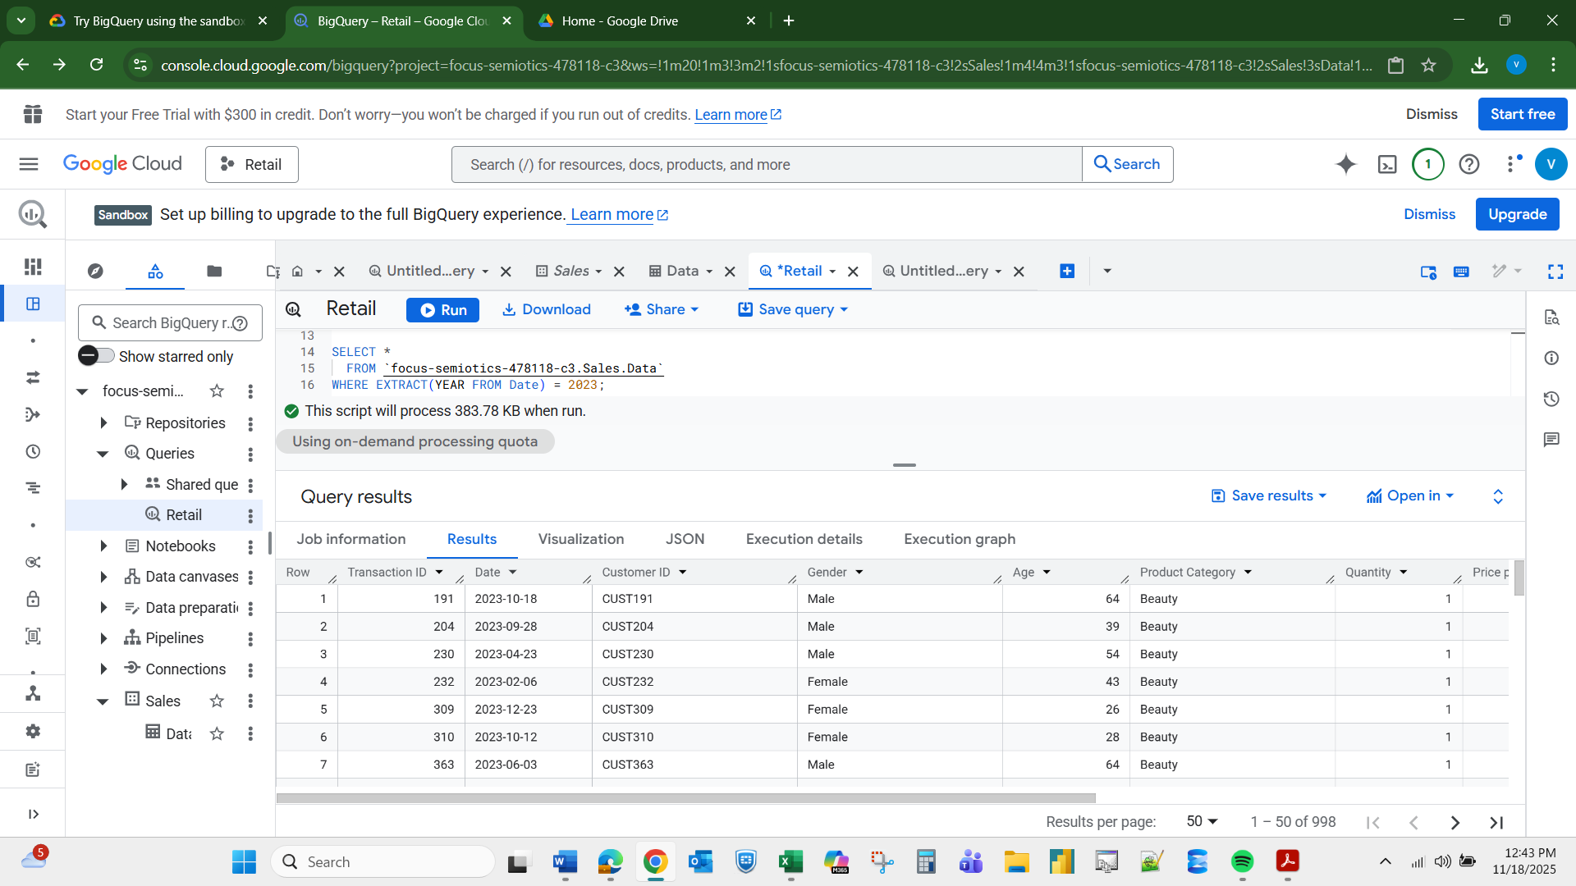

Filtering + Conditions Q2. Display all transactions where the Total Amount is more than the average Total Amount of the entire dataset. Expected output: All columns
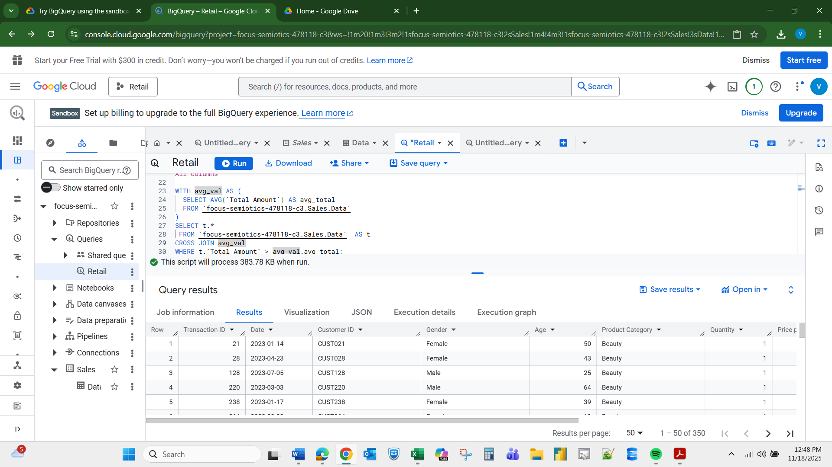
Aggregate Functions Q3. Calculate the total revenue (sum of Total Amount). Expected output: Total Revenue

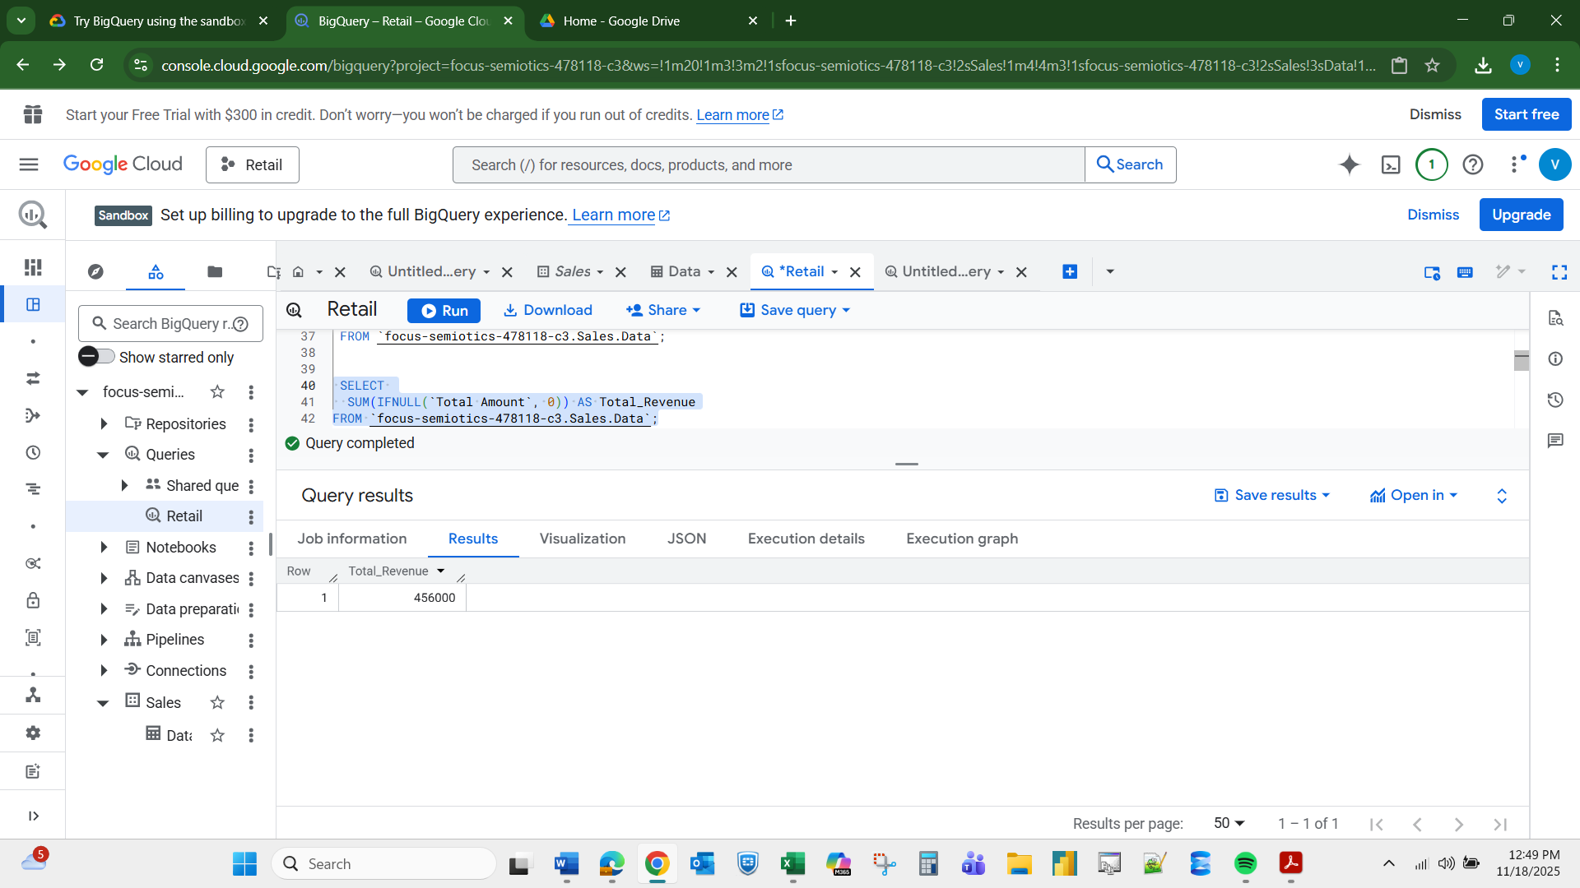
DISTINCT Q4. Display all distinct Product Categories in the dataset. Expected output: Product_Category

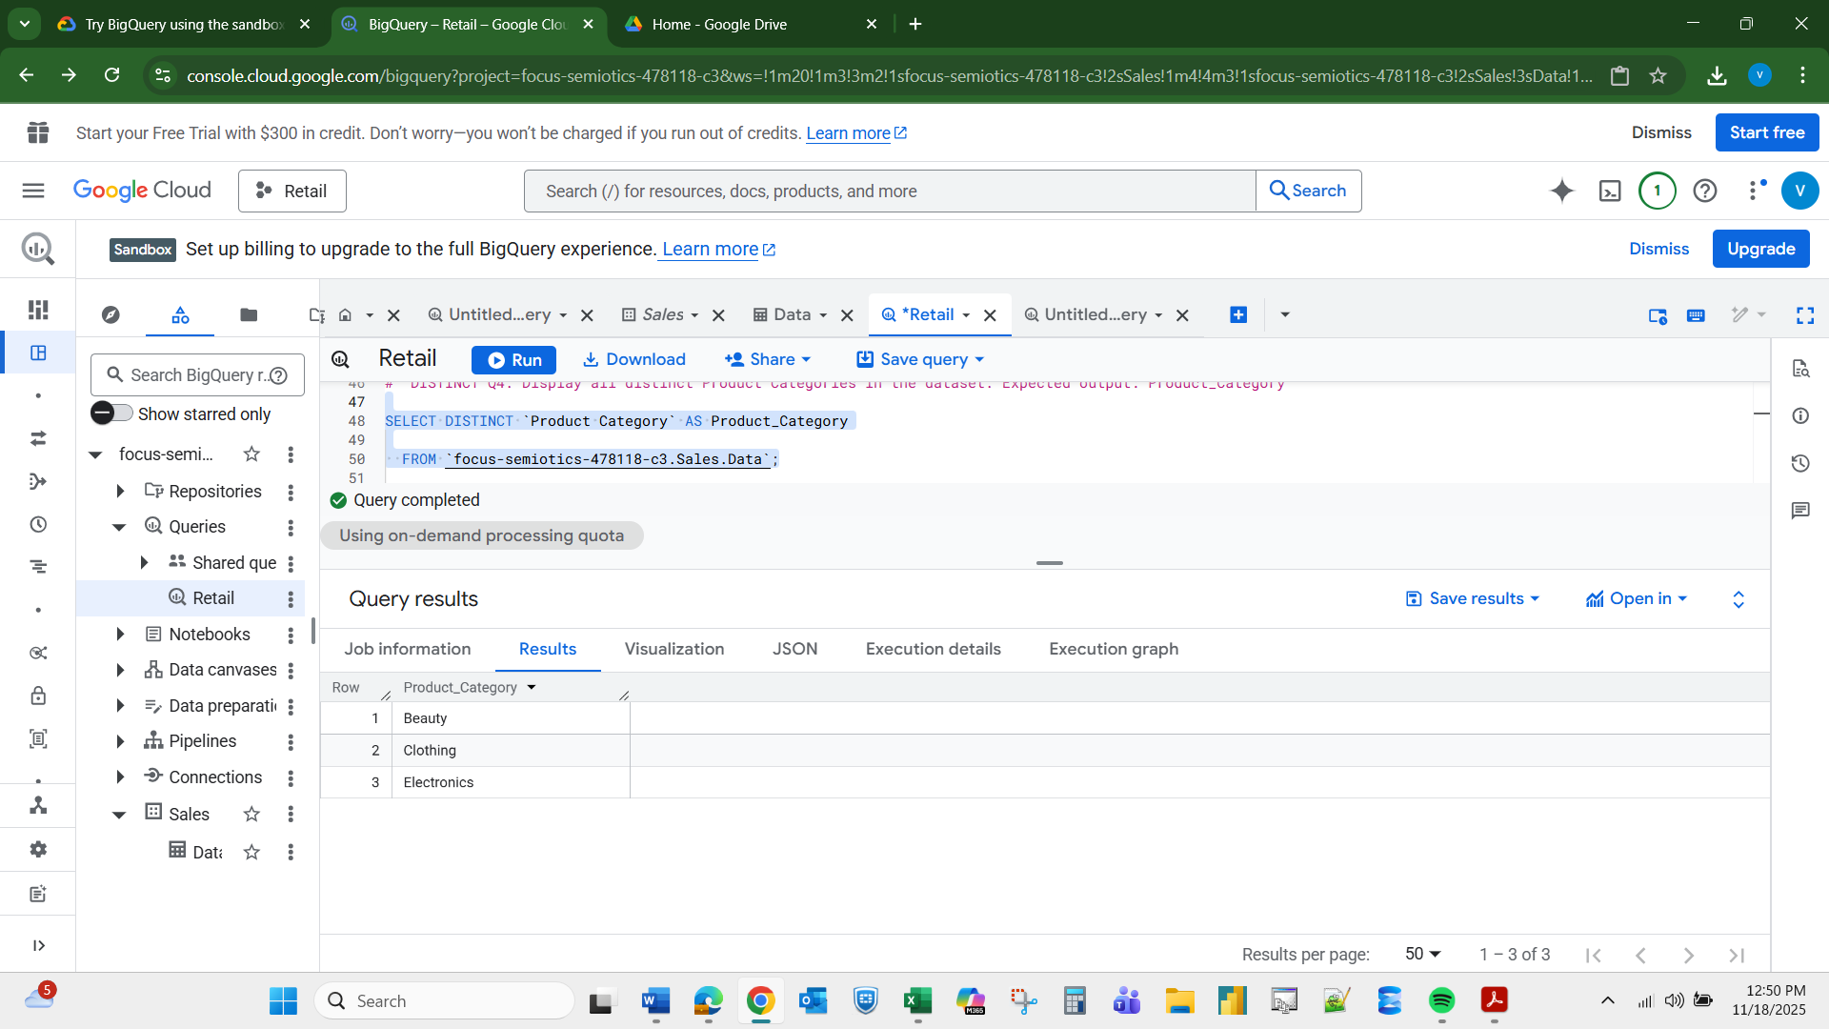
GROUP BY Q5. For each Product Category, calculate the total quantity sold. Expected output: Product Category, Total Quantity

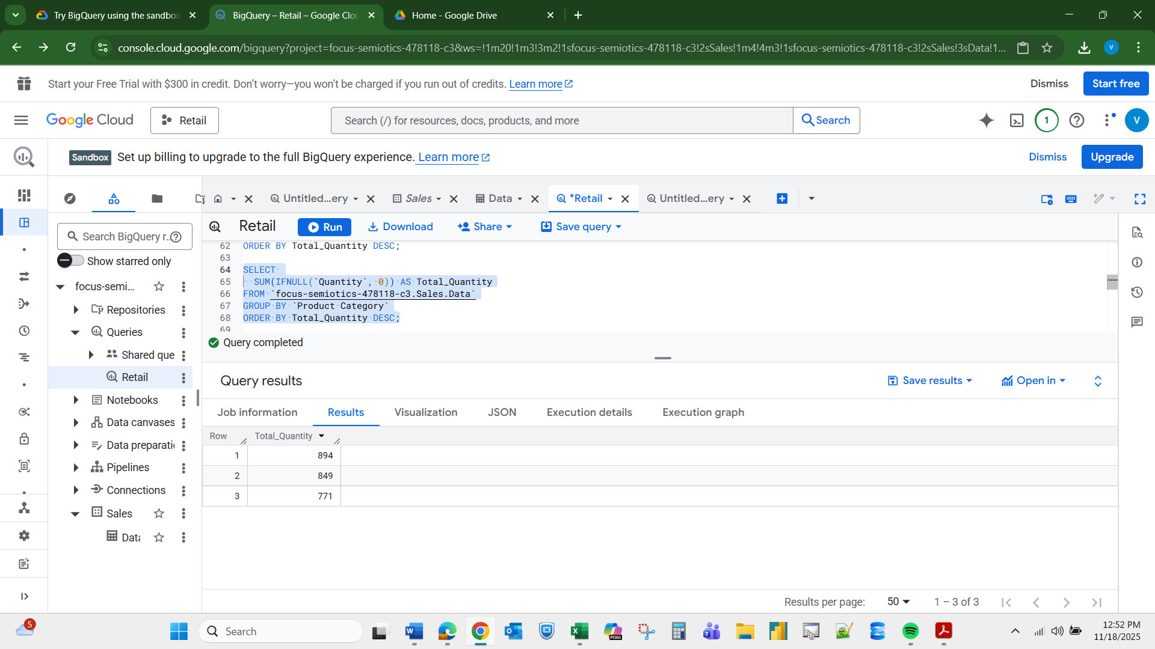
CASE Statement Q6. Create a column called Age Group that classifies customers as ‘Youth’ (<30), ‘Adult’ (30–59), and ‘Senior’ (60+). Expected output: Customer_ID, Age, Age Group

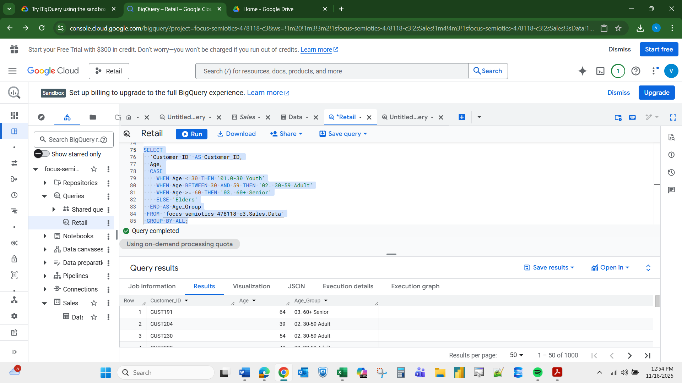
Conditional Aggregation Q7. For each Gender, count how many high-value transactions occurred (where Total Amount > 500). Expected output: Gender, High_Value_Transactions

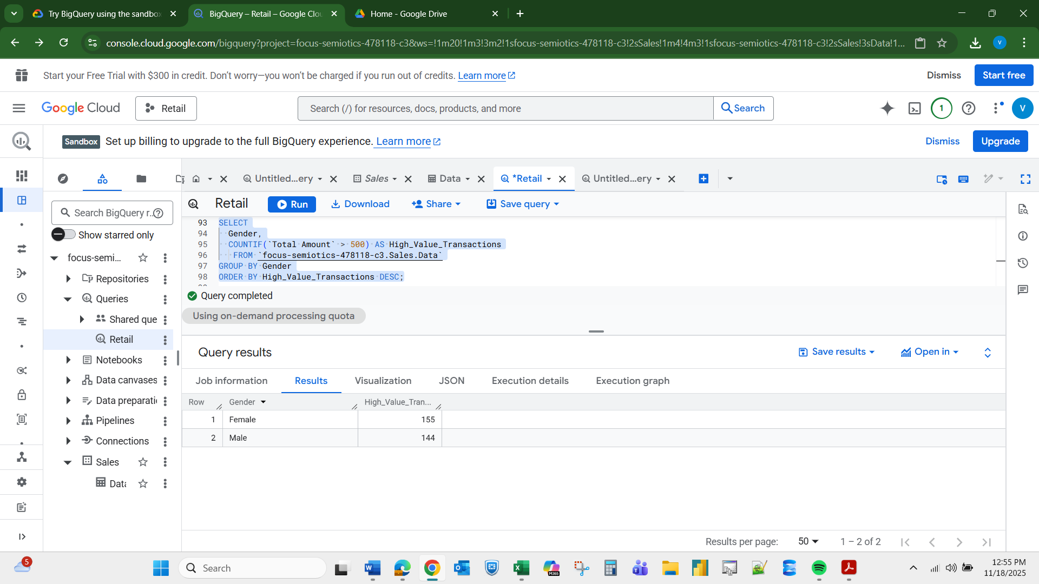
HAVING Clause Q8. For each Product Category, show only those categories where the total revenue exceeds 5,000. Expected output: Product_Category, Total_Revenue

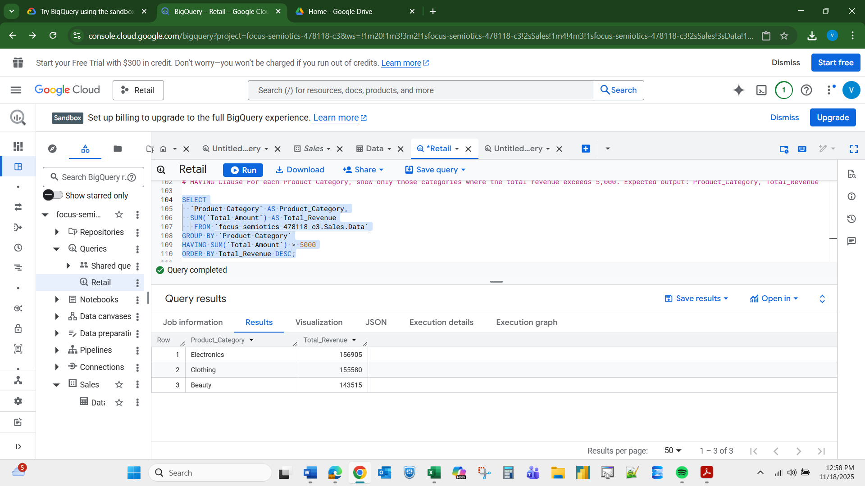
9. Calculated Fields Display a new column called Unit_Cost_Category that labels a transaction as: – 'Cheap' if Price per Unit < 50 – 'Moderate' if Price per Unit between 50 and 200 – 'Expensive' if Price per Unit > 200 Expected output: Transaction_ID, Price_per_Unit, Unit_Cost_Category
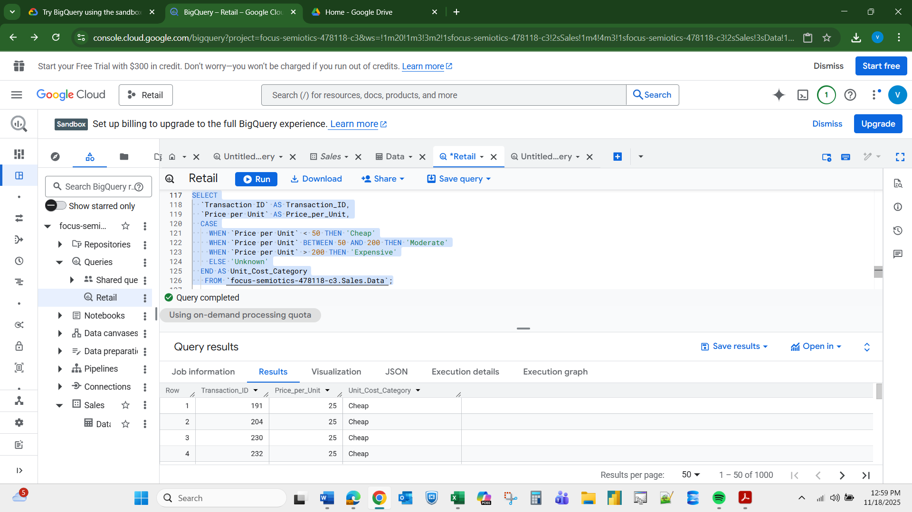
10. Combining WHERE + CASE Display all transactions from customers aged 40 or older and add a column Spending_Level showing ‘High’ if Total Amount > 1000, otherwise ‘Low’. Expected output: Customer_ID, Age, Total_Amount, Spending_Level
